DES-020 DESIGN SPECIFICATION
Item Revision Management

Document Properties
Author | Assootosh Dev Motah
Creation Date | 03/04/2026
Last Updated | 14/05/2026
Document Reference | DES020_5165_Item_Revision_Management
Version | 1.2

Approvals | Position
<Approver 1>
<Approver 2>

Document Control

Change Record
141
Date | Author | Version | Change Reference
03/04/2026 | Assootosh Dev Motah | 1.0 | Création
20/04/2026 | Assootosh Dev Motah | 1.1 | Add revision to UCA9 to PO lines
14/05/2026 | Assootosh Dev Motah | 1.2 | Addition of price management

Relecteurs
Nom | Rôle

Summary
1 Document Control 2
1.1 Change Record 2
1.2 Relecteurs 2
2 General Presentation 4
2.1 Proposed Solution 4
3 Technical Specification 5
3.1 Mashup 5
3.2 Xtend M3 Dynamic Table – EXT001 9
3.3 Xtend M3 API – EXT001MI 10
3.4 MNS260 MBM Initiator 12
3.5 Mapping IEC 13
3.6 Event Configuration 18
3.7 Workflow - WF_5165_UpdateMILOMA 20
3.8 Workflow - WF_5165_GestionPrixAchat_OA 22
3.9 Workflow - WF_5165_GestionPrixAchat_POA 23
3.10 API Flow 23
3.11 H5 Scripts 25
3.12 Script ION 25
4 Points to be determined 26

General Presentation
The purpose of this document is to describe the detailed technical design of the Item Revision Management Interface.
This specification, along with the analysis specification and associated use case specifications, constitutes the complete detailed design for this use case package.

Proposed Solution
The proposed solution involves developing a Mashup (H5SDK), a dynamic table with its respective APIs, IEC mapping, H5 scripts and a workflow to management revisions and automatically update them in purchase orders, planned purchase orders, manufacturing orders and planned manufacturing orders. It will also update the lots in MMS235 with revisions from orders.
Moreover, the price of purchase orders and planned purchase orders are set based on prices and revision preset in PPS100. If a user changes the revision of a purchase order or planned purchase order, the price is automatically retrieved from PPS100 again.

Technical Specification
This specification contains:
- Mashup (H5 SDK)
- XtendM3 dynamic table
- XtendM3 transactions
- H5 scripts
- IEC mapping
- Workflow

Mashup

This mashup will be used to add, display, update and delete information from the table EXT001 about the revisions. Moreover, it will allow the user to launch the batch processing for all revisions or launch processing only for selected rows.

Filters
The input is the Item Number.
- Item number (ITNO)

Revisions DataGrid
There are five columns in the table containing data from EXT001 queried using EXT001MI.LstLine.

Table Data
Data included in the table:
- Item Number:
  - EXT001.ITNO
- Revision
  - EXT001.REVE
- Description:
  - EXT001.TEXT
- Start Date:
  - EXT001.STDT
- Finish Date:
  - EXT001.FSDT

Lookup details
Field | Value
Item Number | API EXPORTMI.Select to retrieve all item numbers for the user’s CONO

Action Button « Search »
The data grid contents are populated through the API call EXT001MI.LstLine to retrieve data from M3.
Fields | Description | Type | Length | Direction | Mandatory | Mapping
ITNO | Item Number | A | 15 | Incoming | N | Item Number
ITNO | Item Nuooomber | A | 15 | Outgoing | - | -
REVE | Revision | A | 4 | Outgoing | - | -
TEXT | Description | A | 60 | Outgoing | - | -
STDT | Start Date | A | 8 | Outgoing | - | -
FSDT | Finish Date | A | 8 | Outgoing | - | -

Action Button « Run Batch »
The batch processing is run using the API MNS260MI.AddMBMInit followed by MNS260MI.PrcMBMInit. These APIs are used to start the IEC mapping.

MNS260MI.AddMBMInit:
Fields | Description | Type | Length | Direction | Mandatory | Mapping
DONR | Document Number | A | 3 | Incoming | Y | ‘MBM’
PRF1 | Media Control Object 1 | A | 17 | Incoming | Y | ‘5165_IRM’
PRTF | Printer file | A | 10 | Incoming | Y | ‘5165_IRM’
OBJC | Field | A | 6 | Incoming | Y | ‘ITNO’
DONO | Document Identity | A | 20 | Incoming | Y | ‘*’
MKF4 | Message Key Field 4 | A | 6 | Incoming | N | ‘REVE’
MKV4 | Message Key Value 4 | A | 20 | Incoming | N | ‘*’
BMIN | MBM initiator name | A | 36 | Outgoing | - | -

MNS260MI.PrcMBMInit:
Fields | Description | Type | Length | Direction | Mandatory | Mapping
BMIN | MBM initiator name | A | 36 | Incoming | Y | -

Action Button « Process Selected Records»
The processing is run for the selected records in the data using the API MNS260MI.AddMBMInit followed by MNS260MI.PrcMBMInit. These APIs are used to start the IEC mapping for selected lines only.

MNS260MI.AddMBMInit:
Fields | Description | Type | Length | Direction | Mandatory | Mapping
DONR | Document Number | A | 3 | Incoming | Y | ‘MBM’
PRF1 | Media Control Object 1 | A | 17 | Incoming | Y | ‘5165_IRM’
PRTF | Printer file | A | 10 | Incoming | Y | ‘5165_IRM’
OBJC | Field | A | 6 | Incoming | Y | ‘ITNO’
DONO | Document Identity | A | 20 | Incoming | Y | Item Number
MKF4 | Message Key Field 4 | A | 6 | Incoming | N | ‘REVE’
MKV4 | Message Key Value 4 | A | 20 | Incoming | N | Revision or ‘*’
BMIN | MBM initiator name | A | 36 | Outgoing | - | -

When more than one line is selected, API is called in bulk with each API call’s MKV4 field containing the revision number. If all lines are selected, the MKV4 field value is set to ‘*’ instead.

MNS260MI.PrcMBMInit:
Fields | Description | Type | Length | Direction | Mandatory | Mapping
BMIN | MBM initiator name | A | 36 | Incoming | Y | -

Action Button « Add»
A pop up appears to allow the user to enter a line. The API call EXT001MI.AddLine is used to add data to M3.
Fields | Description | Type | Length | Direction | Mandatory | Mapping
ITNO | Item Number | A | 15 | Incoming | Y | Item Number
REVE | Revision | A | 4 | Incoming | Y | -
TEXT | Description | A | 60 | Outgoing | - | -
STDT | Start Date | A | 8 | Outgoing | - | -
FSDT | Finish Date | A | 8 | Outgoing | - | -

Action Button « Edit»
A pop up appears to allow the user to enter a line. The API call EXT001MI.UpdLine is used to update data in M3.
Fields | Description | Type | Length | Direction | Mandatory | Mapping
ITNO | Item Number | A | 15 | Incoming | Y | Item Number
REVE | Revision | A | 4 | Incoming | Y | -
TEXT | Description | A | 60 | Outgoing | - | -
STDT | Start Date | A | 8 | Outgoing | - | -
FSDT | Finish Date | A | 8 | Outgoing | - | -

Action Button « Delete»
The API call EXT001MI.Deline is used to delete data in M3.
Fields | Description | Type | Length | Direction | Mandatory | Mapping
ITNO | Item Number | A | 15 | Incoming | N | Item Number
ITNO | Item Number | A | 15 | Outgoing | - | -

Error handling
If the start data is greater than the end date, an error message is sent.
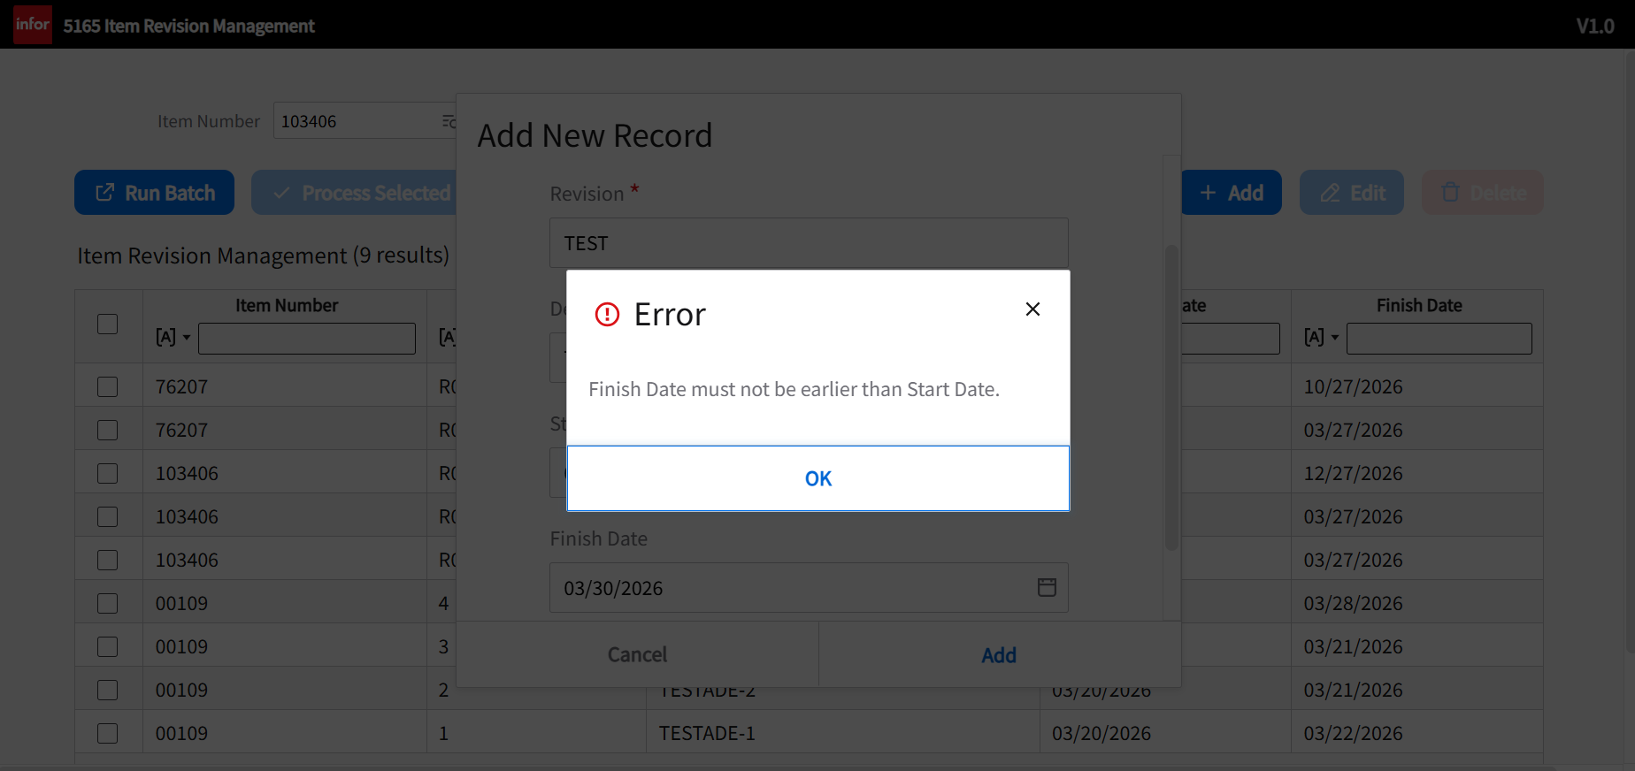

Language consideration
Since PELLENC is an international company, the extension is developed with both French and English translations.

Xtend M3 Dynamic Table – EXT001
This dynamic table is created to store the revisions associated with each item number along with their validity date range.
Name | Description | Type | Length
EXCONO | Company | N | 3
EXITNO | Item Number | A | 15
EXREVE | Revision | A | 4
EXTEXT | Description | A | 60
EXSTDT | Start Date | A | 8
EXFSDT | Finish Date | A | 8

Xtend M3 API – EXT001MI
The development uses the following XtendM3 APIs to maintain the EXT001 table.

AddLine
This transaction adds a unique record to the dynamic table EXT001 using the information listed below.
Input
Name | Type | Length | Mandatory | Description
CONO | N | 3 | False | Company
ITNO | A | 15 | True | Item Number
REVE | A | 4 | True | Revision
TEXT | A | 60 | False | Description
STDT | A | 8 | False | Start Date
FSDT | A | 8 | False | Finish Date

GetLine
This transaction retrieves a row from the dynamic table EXT001.
Input
Name | Type | Length | Mandatory | Description
CONO | N | 3 | False | Company
ITNO | A | 15 | True | Item Number
REVE | A | 4 | True | Revision

Output
Name | Type | Length | Mandatory | Description
CONO | N | 3 | False | Company
ITNO | A | 15 | True | Item Number
REVE | A | 4 | True | Revision
TEXT | A | 60 | False | Description
STDT | A | 8 | False | Start Date
FSDT | A | 8 | False | Finish Date

LstLine
This transaction is used list records from the dynamic table EXT001.
Input
Name | Type | Length | Mandatory | Description
CONO | N | 3 | False | Company
ITNO | A | 15 | False | Item Number

Output
Name | Type | Length | Mandatory | Description
CONO | N | 3 | False | Company
ITNO | A | 15 | True | Item Number
REVE | A | 4 | True | Revision
TEXT | A | 60 | False | Description
STDT | A | 8 | False | Start Date
FSDT | A | 8 | False | Finish Date

UpdLine
This transaction updates a row from the dynamic table EXT001.
Input
Name | Type | Length | Mandatory | Description
CONO | N | 3 | False | Company
ITNO | A | 15 | True | Item Number
REVE | A | 4 | True | Revision
TEXT | A | 60 | False | Description
STDT | A | 8 | False | Start Date
FSDT | A | 8 | False | Finish Date

DelLine
This transaction deletes a row from the dynamic table EXT001.
Input
Name | Type | Length | Mandatory | Description
CONO | N | 3 | False | Company
ITNO | A | 15 | True | Item Number
REVE | A | 4 | True | Revision

MNS260 MBM Initiator

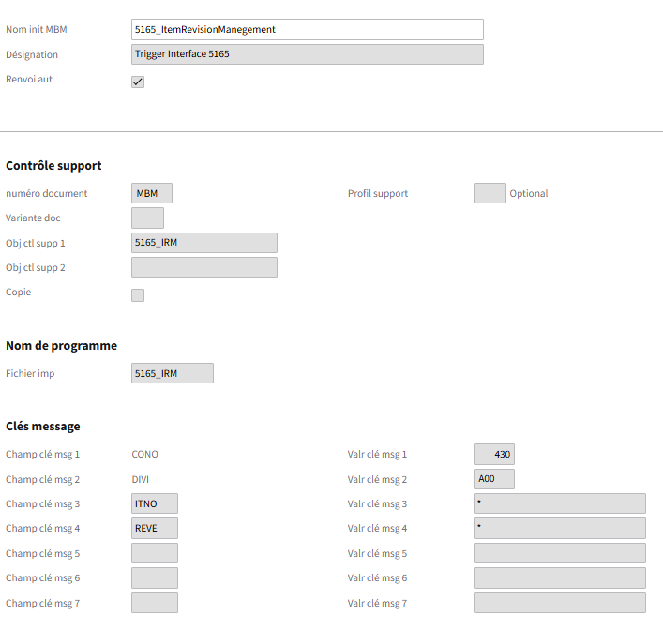

The calculation will be initiated by the MBM initiator "5165_ItemRevisionManagement".
This program can be run on a scheduled basis or manually for a specific item by entering the item number (ITNO) and the revision number (REVE) in message fields 3 and 4, respectively.

Mapping IEC
The mapping’s goal is to add the revision to all purchase order, planned purchase order, manufacturing order and planned manufacturing order in a CUGEX field related to them. It will be able to add revisions for one item or for all items created in the EXT001 table. It will also update the prices for purchase orders and planned purchase orders.

The following diagram explains the main logic of the IEC mapping:

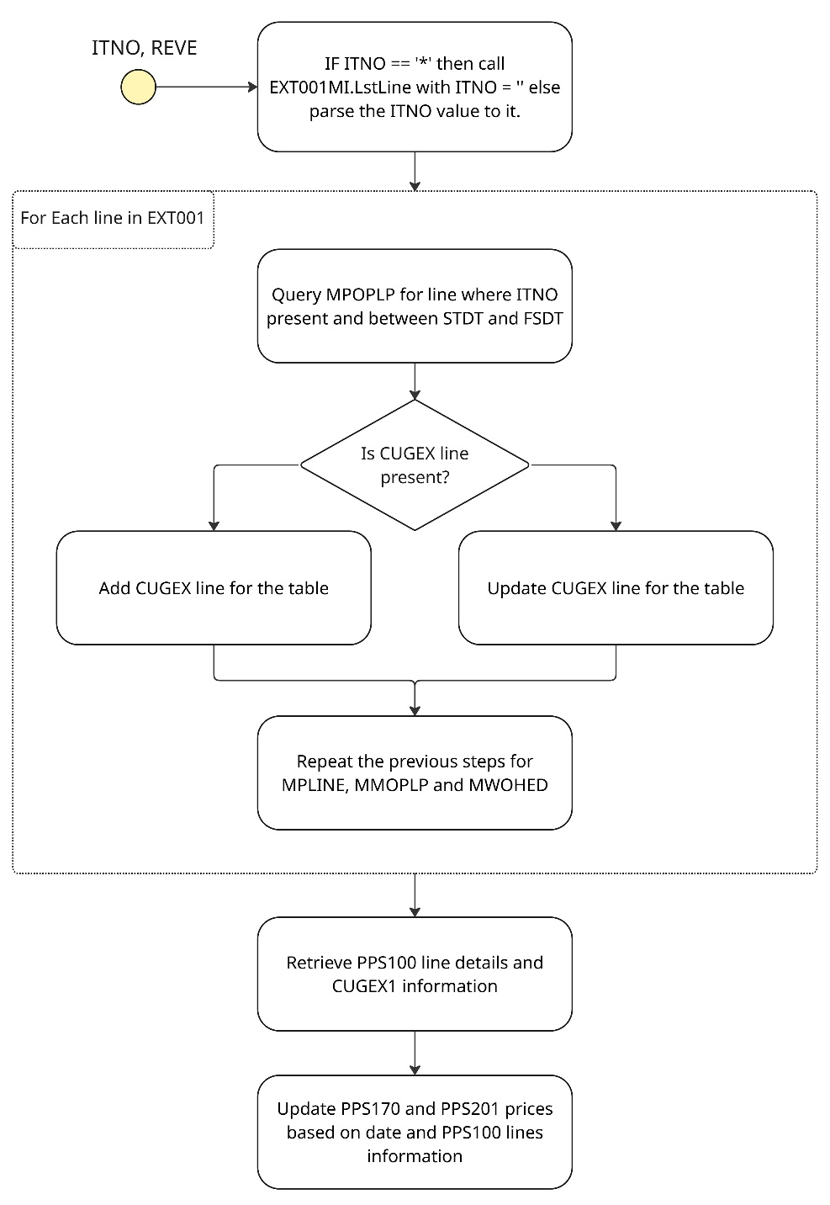

The following are the details of APIs sued in the mapping:

EXT001MI.LstLine
This API is used to get the revisions from the table EXT001.
Field | Direction | Mandatory | Mapping
ITNO | Incoming | Y | -
ITNO | Outgoing | - | -
REVE | Outgoing | - | -
TEXT | Outgoing | - | -
STDT | Outgoing | - | -
FSDT | Outgoing | - | -

PPS100MI.LstAgrLine
This API is used to list line details from PPS100.
Field | Direction | Mandatory | Mapping
SUNO | Incoming | Y | -
OURR | Incoming | N | -
FVDT | Outgoing | - | -
UVDT | Outgoing | - | -
PUPR | Outgoing | - | -

PPS170MI.SearchPOP
This API is used to query the table MPOPLP.
The format of SQRY is “ITNO: <Item Number> AND DLDT : [ <Start Date> TO <Finish Date>]”.
Field | Direction | Mandatory | Mapping
SQRY | Incoming | Y | -
PLPN | Outgoing | - | -

PPS170MI.GetPlannedPO
This API is used update a planned purchase order.
Field | Direction | Mandatory | Mapping
PLPN | Incoming | Y | -
PLPN | Incoming | N | -
PLPN | Incoming | N | -
ITNO | Outgoing | - | -
OURR | Outgoing | - | -
SUNO | Outgoing | - | -

PPS170MI.UpdPlannedPO
This API is used update a planned PO.
Field | Direction | Mandatory | Mapping
PLPN | Incoming | Y | -
PLPN | Incoming | N | -
PLPN | Incoming | N | -
PUPR | Incoming | N | -

PPS200MI.SearchLine
This API is used to query the table MPLINE.
The format of SQRY is “ITNO: <Item Number> AND PUSL:[0 TO 19] AND DWDT: [ <Start Date> TO <Finish Date>]”.
Field | Direction | Mandatory | Mapping
SQRY | Incoming | Y | -
PUNO | Outgoing | - | -
PNLI | Outgoing | - | -
PNLS | Outgoing | - | -

PPS200MI.GetHead
This API is used retrieve the date of the PO.
Field | Direction | Mandatory | Mapping
PUNO | Incoming | Y | -
PUDT | Outgoing | - | -

PPS200MI.GetLine
This API is used retrieve the line information of the PO.
Field | Direction | Mandatory | Mapping
PUNO | Incoming | Y | -
PNLI | Incoming | N | -
PNLS | Incoming | N | -
ITNO | Outgoing | - | -
SUNO | Outgoing | - | -
OURR | Outgoing | - | -

PPS200MI.UpdLine
This API is used to update the revision in MPLINE
Field | Direction | Mandatory | Mapping
PUNO | Incoming | Y | -
PNLI | Incoming | N | -
PNLS | Incoming | N | -
UCA9 | Incoming | N | -

PMS100MI.SearchMO
This API is used to query the table MWOHED.
The format of SQRY is “ITNO: <Item Number> AND WHST:[0 TO 20] AND WODP:0 AND STDT: [ <Start Date> TO <Finish Date>]”.
Field | Direction | Mandatory | Mapping
SQRY | Incoming | Y | -
FACI | Outgoing | - | -
MFNO | Outgoing | - | -
PRNO | Outgoing | - | -

CUSEXTMI.GetAlphaKPI
This API is used to query the table CUGEX3.
Field | Direction | Mandatory | Mapping
KPID | Incoming | Y | -
PK01 | Incoming | Y | -
PK02 | Incoming | - | -
PK03 | Incoming | - | -

CUSEXTMI.AddAlphaKPI
This API is used to add a line to the table CUGEX3.
Field | Direction | Mandatory | Mapping
KPID | Incoming | Y | -
PK01 | Incoming | Y | -
PK02 | Incoming | - | -
PK03 | Incoming | - | -
AL30 | Incoming | Y | -

CUSEXTMI.UpdAlphaKPI
This API is used to update a line to the table CUGEX3.
Field | Direction | Mandatory | Mapping
KPID | Incoming | Y | -
PK01 | Incoming | Y | -
PK02 | Incoming | - | -
PK03 | Incoming | - | -
AL30 | Incoming | Y | -

CUSEXTMI.GetFieldValue
This API is used to query the table CUGEX1.
Field | Direction | Mandatory | Mapping
KPID | Incoming | Y | -
PK01 | Incoming | Y | -
PK02 | Incoming | - | -
PK03 | Incoming | - | -
A030 | Outgoing | - | -

CUSEXTMI.LstFieldValue
This API is used to query the table CUGEX1 for PPS100.
Field | Direction | Mandatory | Mapping
KPID | Incoming | Y | -
PK01 | Incoming | Y | -
PK02 | Incoming | - | -
PK03 | Incoming | - | -
A030 | Outgoing | - | -

CUSEXTMI.AddFieldValue
This API is used to add a line to the table CUGEX1.
Field | Direction | Mandatory | Mapping
KPID | Incoming | Y | -
PK01 | Incoming | Y | -
PK02 | Incoming | - | -
PK03 | Incoming | - | -
A030 | Incoming | Y | -

CUSEXTMI.UpdFieldValue
This API is used to update a line to the table CUGEX1.
Field | Direction | Mandatory | Mapping
KPID | Incoming | Y | -
PK01 | Incoming | Y | -
PK02 | Incoming | - | -
PK03 | Incoming | - | -
A030 | Incoming | Y | -

Event Configuration
CMS045
Table MILOMA - Create:
Event name | MILOMA
Event operation | C
Event publisher | M3
Status | 20-Approved
Include in auto job event alerts (CMS911) | Selected
Include in auto job event DB changes (CMS912) | Selected

Table CUGEX3 – Create and Update:
Event name | CUGEX3
Event operation | CU
Event publisher | M3
Status | 20-Approved
Include in auto job event alerts (CMS911) | Selected
Include in auto job event DB changes (CMS912) | Selected

Table MPLINE –Update:
Event name | MPLINE
Event operation | U
Event publisher | M3
Status | 20-Approved
Include in auto job event alerts (CMS911) | Selected
Include in auto job event DB changes (CMS912) | Selected

CMS047
Table MILOMA - Create:
Event publisher | M3
Event name | MILOMA
Alert rule ID | 5165_IRM
Event operation | C
Detailed Information
Description | WF_5165_UpdateMILOMA
Name | WF_5165_UpdateM
Status | 20-Approved
BOD enabled | Selected. 4-Workflow
Workflow name | WF_5165_UpdateMILOMA
Logical Formula
Receiver | E_ASSMOT
Table | MILOMA

Table MPLINE - Update:
Event publisher | M3
Event name | MPLINE
Alert rule ID | 5165_OA
Event operation | U
Detailed Information
Description | Trigger on change of revision no
Name | 5165_OA
Status | 20-Approved
BOD enabled | Selected. 4-Workflow
Workflow name | WF_5165_GestionPrixAchat_OA
Logical Formula | UCA9 changed value AND PUSL less than 20 AND CHID does not equal MECSVC
Receiver | E_ASSMOT
Table | MPLINE

Table CUGEX3 – Create and Update:
Event publisher | M3
Event name | CUGEX3
Alert rule ID | 5165_POA
Event operation | CU
Detailed Information
Description | Trigger on change of revision no
Name | 5165_OA
Status | 20-Approved
BOD enabled | Selected. 4-Workflow
Workflow name | WF_5165_GestionPrixAchat_POA
Logical Formula | KPID equals 5165_MPOPLP AND A030 changed value AND CHID does not equal MECSVC
Alert Message | <A030>
Receiver | E_ASSMOT
Table | CUGEX3

Workflow - WF_5165_UpdateMILOMA

The workflow WF_5165_UpdateMILOMA is used in this interface to automatically add revisions to lots created in MMS235.

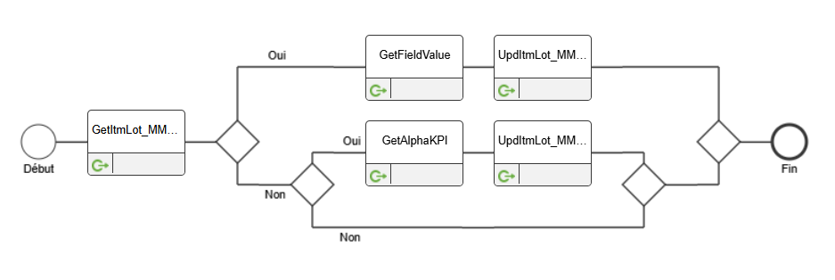

The RORC, RODN, RODL, RORX and FACI are obtained from the lot using the API MMS235MI.GetItmLot.
If RORC equals to 1 then we get the revision from CUGEX1 of the table MWOHED and update the BRE2 field using the API MMS235MI.UpdItmLot.
If RORC equals to 2 then we get the revision from CUGEX3 of the table MPLINE and update the BRE2 field using the API MMS235MI.UpdItmLot.

MMS235MI.GetItmLot
This API is used to get information about the lot in MMS235.
Field | Direction | Mandatory | Mapping
ITNO | Incoming | Y | -
BANO | Incoming | Y | -

MMS235MI.UpdItmLot
This API is used to get information about the lot in MMS235.
Field | Direction | Mandatory | Mapping
ITNO | Incoming | Y | -
BANO | Incoming | Y | -
BRE2 | Incoming | N | -

CUSEXTMI.GetFieldValue
This API is used to query the table CUGEX1.
Field | Direction | Mandatory | Mapping
KPID | Incoming | Y | -
PK01 | Incoming | Y | -
PK02 | Incoming | - | -
PK03 | Incoming | - | -

CUSEXTMI.GetAlphaKPI
This API is used to query the table CUGEX3.
Field | Direction | Mandatory | Mapping
KPID | Incoming | Y | -
PK01 | Incoming | Y | -
PK02 | Incoming | - | -
PK03 | Incoming | - | -

Workflow - WF_5165_GestionPrixAchat_OA
The workflow WF_5165_GestionPrixAchat_OA is used in this interface to automatically update the price of purchase orders when their revision number has been changed. It will call and API flow to make the update in PPS201.

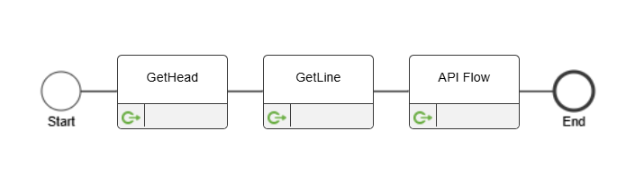

PPS200MI.GetHead
This API is used to get the date of the purchase order head.
Field | Direction | Mandatory | Mapping
PUNO | Incoming | Y | -
PUDT | Outgoing | - | -

PPS200MI.GetLine
This API is used to get the purchase order line information.
Field | Direction | Mandatory | Mapping
PUNO | Incoming | Y | -
PNLI | Incoming | N | -
PUNO | Incoming | N | -
UCA9 | Outgoing | - | -
ITNO | Outgoing | - | -
SUNO | Outgoing | - | -
OURR | Outgoing | - | -

Workflow - WF_5165_GestionPrixAchat_POA
The workflow WF_5165_GestionPrixAchat_POA is used in this interface to automatically update the price of planned purchase orders when their revision number has been changed. Today’s date is retrieved using a script in the right format. Afterwards, it will call and API flow to make the update in PPS170.

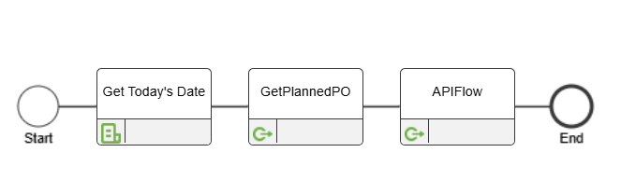

PPS170MI.GetPlannedPO
This API is used to get planned purchase order information.
Field | Direction | Mandatory | Mapping
PLPN | Incoming | Y | -
PLPS | Incoming | N | -
PLP2 | Incoming | N | -
ITNO | Outgoing | - | -
OURR | Outgoing | - | -
SUNO | Outgoing | - | -

API Flow
The API Flow AF_5165_Gestion_Prix_Achat retrieves the revision number from the PPS100 lines concerned as well as their details. Afterwards, it gets the price from the line based on the date entered. Then either the planned purchase order or purchase order are updated based on the flag parsed into the API Flow.

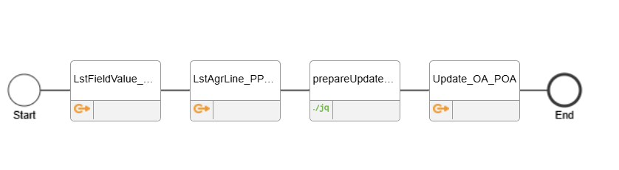

CUSEXTMI.LstFieldValue
This API is used to retrieve the revision number from PPS101.
Field | Direction | Mandatory | Mapping
FILE | Incoming | Y | MPAGRL
PK01 | Incoming | Y | -
PK02 | Incoming | N | -
A030 | Outgoing | - | -

PPS100MI.LstAgrLine
This API is used to retrieve the PPS101 lines associated with the PO/PPO.
Field | Direction | Mandatory | Mapping
SUNO | Incoming | Y | -
AGNO | Incoming | N | -
FVDT | Outgoing | - | -
UVDT | Outgoing | - | -
PUPR | Outgoing | - | -
SUNO | Outgoing | - | -
AGNB | Outgoing | - | -
GRPI | Outgoing | - | -
OBV1 | Outgoing | - | -
OBV2 | Outgoing | - | -
OBV3 | Outgoing | - | -

PPS170MI.UpdPlannedPO
This API is used to update the price of the planned purchase order.
Field | Direction | Mandatory | Mapping
PLPN | Incoming | Y | -
PLPS | Incoming | N | -
PLP2 | Incoming | N | -
PUPR | Outgoing | - | -

PPS200MI.UpdLine
This API is used to update the price of the purchase order line.
Field | Direction | Mandatory | Mapping
PUNO | Incoming | Y | -
PNLI | Incoming | N | -
PNLS | Incoming | N | -
PUPR | Outgoing | - | -

H5 Scripts
This section describes the scripts that are being used for this interface.
- SCR_5165_GetIndice_MMOPLP
This is used to add a field named Indice containing data from CUGEX3 where KPID = ‘5165_MMOPLP’ and PK01 = PLPN.
When the user edits the value in the field and press <Enter> or the Next button, it updated the value of the revision in CUGEX3.
- SCR_5165_GetIndice_MPLINE
This is used to add a field named Indice containing data from MPLINE where PUNO = PUNO, PNLI = PNLI and PNLS = PNLS.
When the user edits the value in the field and press <Enter> or the Next button, it updated the value of the revision in MPLINE.
- SCR_5165_GetIndice_MPOPLP
This is used to add a field named Indice containing data from CUGEX3 where KPID = ‘5165_MPLINE’ and PK01 = PLPN, PK02 = PLPS.
When the user edits the value in the field and press <Enter> or the Next button, it updated the value of the revision in CUGEX3.

Script ION

- 5165_GetDate
This script gets today’s date and return it in the YYYYMMDD format.
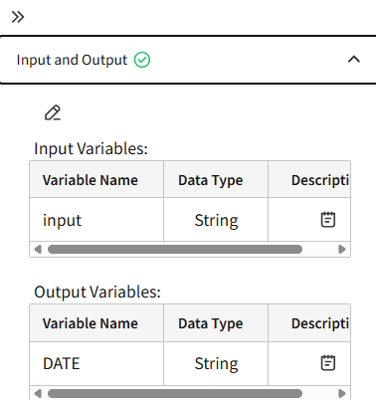

Points to be determined

